**SPRING CORE AND MAVEN – HANDS ON SOLUTION**

**Exercise 1: Configuring a Basic Spring Application**

**XML:**

<?xml version="1.0" encoding="UTF-8"?>

<beans xmlns="http://www.springframework.org/schema/beans"

xmlns:xsi="http://www.w3.org/2001/XMLSchema-instance"

xsi:schemaLocation="

http://www.springframework.org/schema/beans

http://www.springframework.org/schema/beans/spring-beans.xsd">

<bean id="bookRepository" class="com.library.repository.BookRepository" />

<bean id="bookService" class="com.library.service.BookService">

<property name="bookRepository" ref="bookRepository" />

</bean>

</beans>

**BookRepository:**

package com.library.repository;

public class BookRepository {

public void save(String bookName) {

System.out.println("Saving book: " + bookName);

}

}

**BookService:**

package com.library.service;

import com.library.repository.BookRepository;

public class BookService {

private BookRepository bookRepository;

public void setBookRepository(BookRepository bookRepository) {

this.bookRepository = bookRepository;

}

public void addBook(String bookName) {

bookRepository.save(bookName);

}

}

**LibraryApplication:**

package com.library;

import org.springframework.context.ApplicationContext;

import org.springframework.context.support.ClassPathXmlApplicationContext;

import com.library.service.BookService;

public class LibraryApplication {

public static void main(String[] args) {

ApplicationContext context = new ClassPathXmlApplicationContext("applicationContext.xml");

BookService bookService = context.getBean("bookService", BookService.class);

bookService.addBook("Java in Action");

}

}

**OUTPUT:**

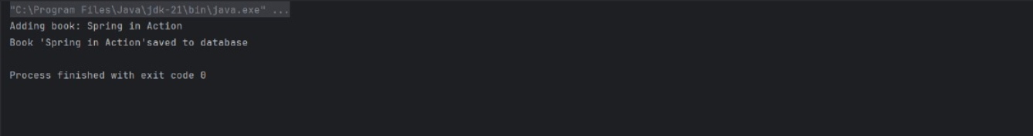

**EXERCISE 2: IMPLEMENTING DEPENDENCY INJECTION :**

**Xml**

<?xml version="1.0" encoding="UTF-8"?>

<beans xmlns="http://www.springframework.org/schema/beans"

xmlns:xsi="http://www.w3.org/2001/XMLSchema-instance"

xsi:schemaLocation="http://www.springframework.org/schema/beans

http://www.springframework.org/schema/beans/spring-beans.xsd">

<!-- Define BookRepository bean -->

<bean id="bookRepository" class="com.library.repository.BookRepository" />

<!-- Define BookService bean and inject BookRepository -->

<bean id="bookService" class="com.library.service.BookService">

<property name="bookRepository" ref="bookRepository"/>

</bean>

</beans>

**BookService:**

package com.library.service;

import com.library.repository.BookRepository;

public class BookService {

private BookRepository bookRepository;

public void setBookRepository(BookRepository bookRepository) {

this.bookRepository = bookRepository;

}

public void addBook(String bookName) {

bookRepository.save(bookName);

}

}

**BookRepository:**

package com.library.repository;

public class BookRepository {

public void save(String bookName) {

System.out.println("Saving book: " + bookName);

}

}

**LibraryApplication:**

package com.library;

import org.springframework.context.ApplicationContext;

import org.springframework.context.support.ClassPathXmlApplicationContext;

import com.library.service.BookService;

public class LibraryApplication {

public static void main(String[] args) {

ApplicationContext context = new ClassPathXmlApplicationContext("applicationContext.xml");

BookService bookService = context.getBean("bookService", BookService.class);

bookService.addBook("Spring in Action");

}

}

**OUTPUT:**

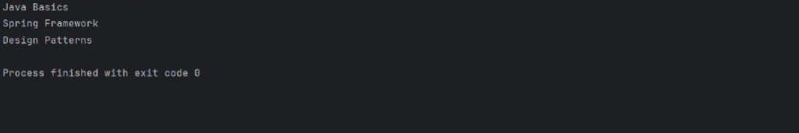

**EXERCISE 4: CREATING AND CONFIGURING A MAVEN PROJECT :**

**Xml:**

<project xmlns="http://maven.apache.org/POM/4.0.0"

xmlns:xsi="http://www.w3.org/2001/XMLSchema-instance"

xsi:schemaLocation="http://maven.apache.org/POM/4.0.0

http://maven.apache.org/xsd/maven-4.0.0.xsd">

<modelVersion>4.0.0</modelVersion>

<groupId>com.library</groupId>

<artifactId>librarymanagement</artifactId>

<version>1.0-SNAPSHOT</version>

<packaging>jar</packaging>

<properties>

<java.version>1.8</java.version>

</properties>

<dependencies>

<!-- Spring Core & Context -->

<dependency>

<groupId>org.springframework</groupId>

<artifactId>spring-context</artifactId>

<version>5.3.32</version>

</dependency>

<!-- Spring AOP -->

<dependency>

<groupId>org.springframework</groupId>

<artifactId>spring-aop</artifactId>

<version>5.3.32</version>

</dependency>

<!-- Spring Web MVC -->

<dependency>

<groupId>org.springframework</groupId>

<artifactId>spring-webmvc</artifactId>

<version>5.3.32</version>

</dependency>

<!-- Optional: JUnit for testing -->

<dependency>

<groupId>junit</groupId>

<artifactId>junit</artifactId>

<version>4.13.2</version>

<scope>test</scope>

</dependency>

</dependencies>

<build>

<plugins>

<!-- Maven Compiler Plugin -->

<plugin>

<groupId>org.apache.maven.plugins</groupId>

<artifactId>maven-compiler-plugin</artifactId>

<version>3.11.0</version>

<configuration>

<source>1.8</source>

<target>1.8</target>

</configuration>

</plugin>

</plugins>

</build>

</project>

**BookRepository:**

package com.library.repository;

public class BookRepository {

public void save(String bookName) {

System.out.println("Book saved: " + bookName);

}

}

**BookService:**

package com.library.service;

import com.library.repository.BookRepository;

public class BookService {

private BookRepository bookRepository;

public void setBookRepository(BookRepository bookRepository) {

this.bookRepository = bookRepository;

}

public void addBook(String bookName) {

bookRepository.save(bookName);

}

}

**LibraryApplication:**

package com.library;

import org.springframework.context.ApplicationContext;

import org.springframework.context.support.ClassPathXmlApplicationContext;

import com.library.service.BookService;

public class LibraryApplication {

public static void main(String[] args) {

ApplicationContext context = new ClassPathXmlApplicationContext("applicationContext.xml");

BookService bookService = (BookService) context.getBean("bookService");

bookService.addBook("The Great Gatsby");

}

}

**OUTPUT:**

